Module 5: Spring Core and Maven
Exercise 1: Configuring a Basic Spring Application
Scenario:
Your company is developing a web application for managing a library. You need to use the Spring Framework to handle the backend operations.
BookRepository.java
package com.library.repository;
public class BookRepository {
public BookRepository() {
System.out.println("BookRepository initialized");
}
public String findBookById(int id) {
return "Book with ID " + id + " - 'Spring in Action'";
}
}
BookService.java
package com.library.service;
import com.library.repository.BookRepository;
public class BookService {
private BookRepository bookRepository;
public void setBookRepository(BookRepository bookRepository) {
this.bookRepository = bookRepository;
}
public String getBookDetails(int id) {
return bookRepository.findBookById(id);
}
}

applicationContext.xml
<?xml version="1.0" encoding="UTF-8"?>
<beans xmlns="http://www.springframework.org/schema/beans"
xmlns:xsi="http://www.w3.org/2001/XMLSchema-instance"
xsi:schemaLocation="http://www.springframework.org/schema/beans
http://www.springframework.org/schema/beans/spring-beans.xsd">
<bean id="bookRepository" class="com.library.repository.BookRepository"/>
<bean id="bookService" class="com.library.service.BookService">
<property name="bookRepository" ref="bookRepository"/>
</bean>
</beans>

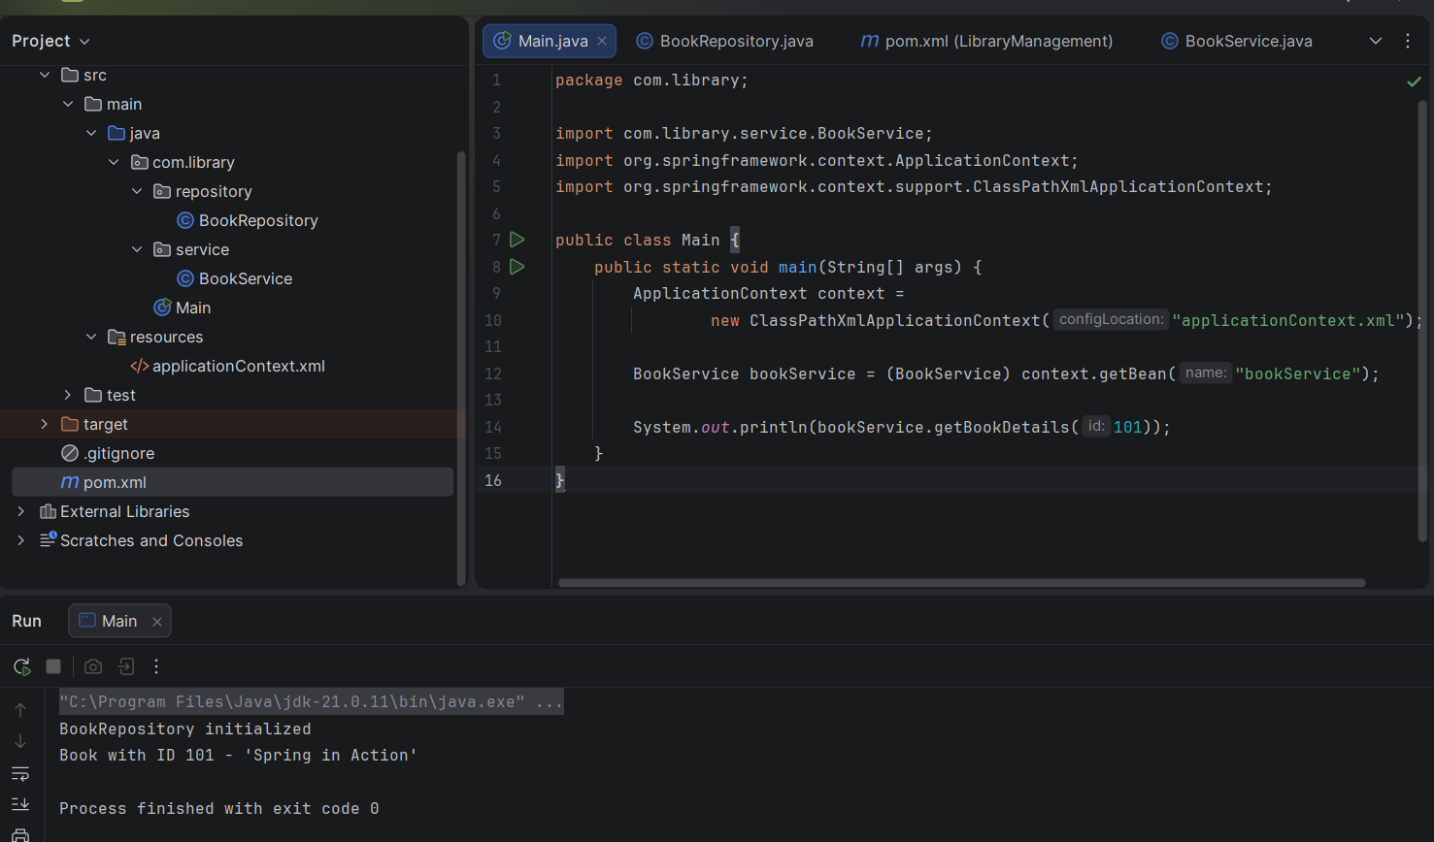
Exercise 2: Implementing Dependency Injection
Scenario:
In the library management application, you need to manage the dependencies between the BookService and BookRepository classes using Spring's IoC and DI.
applicationContext.java
<?xml version="1.0" encoding="UTF-8"?>
<beans xmlns="http://www.springframework.org/schema/beans"
xmlns:xsi="http://www.w3.org/2001/XMLSchema-instance"
xsi:schemaLocation="http://www.springframework.org/schema/beans
http://www.springframework.org/schema/beans/spring-beans.xsd">
<bean id="bookRepository" class="com.library.repository.BookRepository"/>
<bean id="bookService" class="com.library.service.BookService">
<property name="bookRepository" ref="bookRepository"/>
</bean>
</beans>
BookService.java
package com.library.service;
import com.library.repository.BookRepository;
public class BookService {
private BookRepository bookRepository;
public void setBookRepository(BookRepository bookRepository) {
this.bookRepository = bookRepository;
System.out.println("BookRepository injected into BookService");
}
public BookRepository getBookRepository() {
return bookRepository;
}
public String getBookDetails(int id) {
if (bookRepository == null) {
throw new IllegalStateException("BookRepository was not injected!");
}
return bookRepository.findBookById(id);
}
}
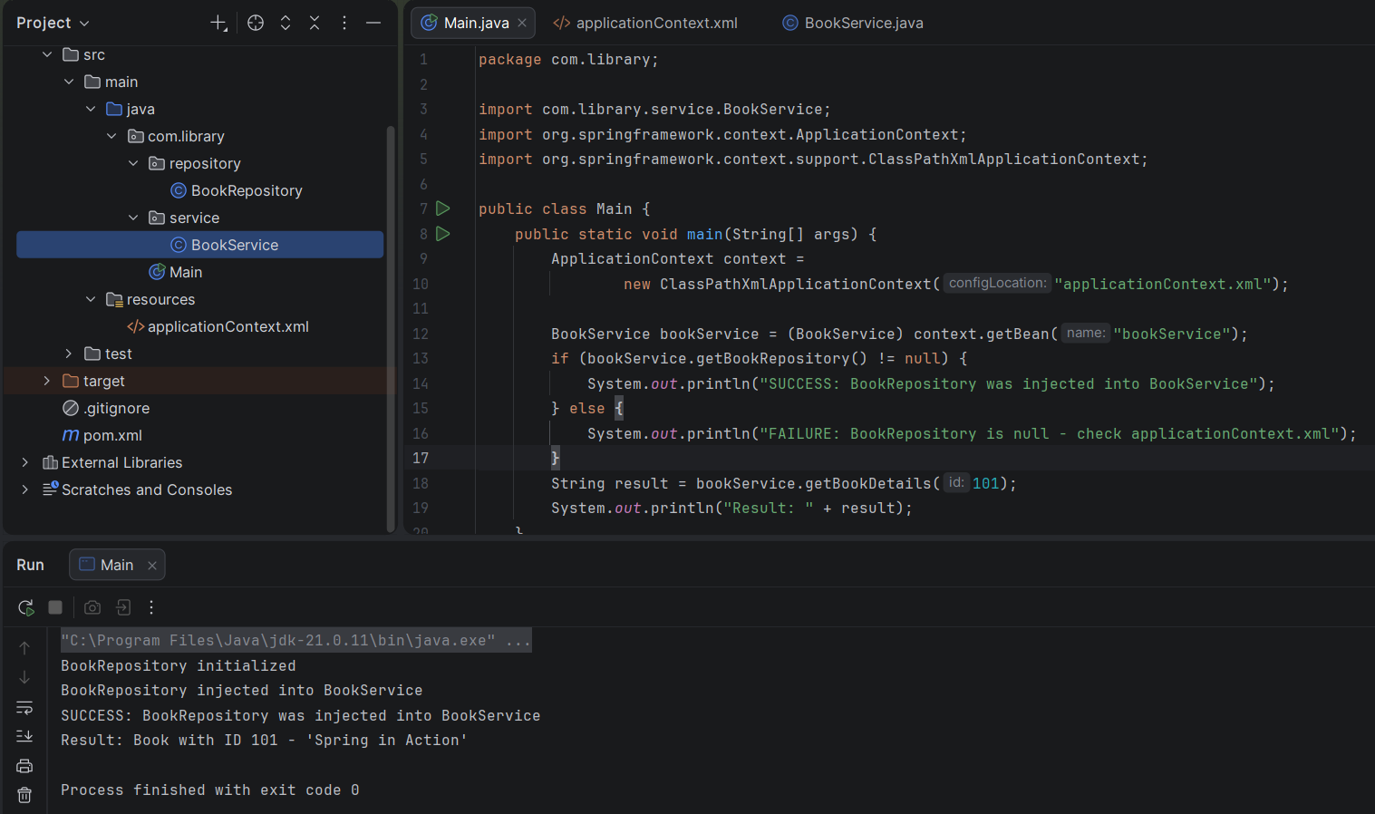

Exercise 4: Creating and Configuring a Maven Project
Scenario:
You need to set up a new Maven project for the library management application and add Spring dependencies.
Pom.xml
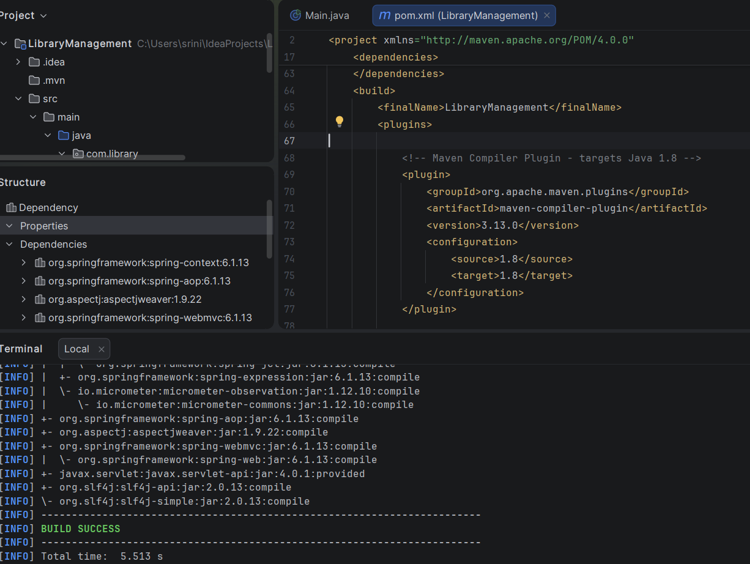
Exercise 5: Configuring the Spring IoC Container
Scenario:
The library management application requires a central configuration for beans and dependencies.
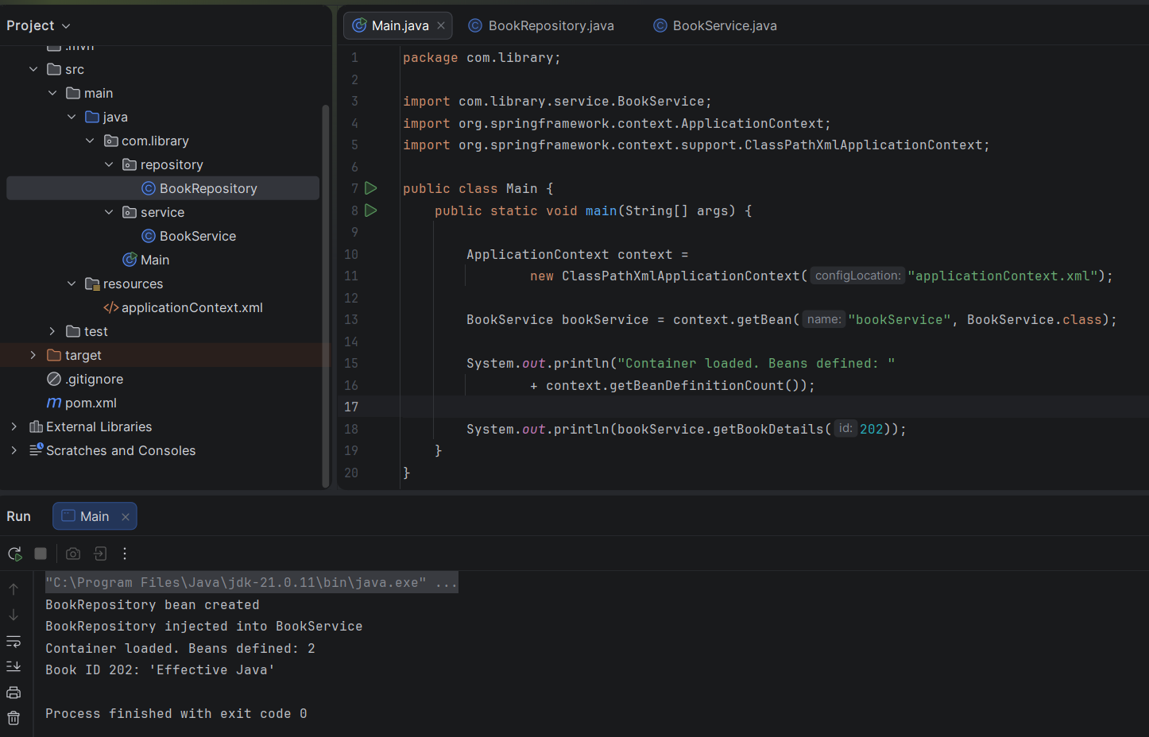
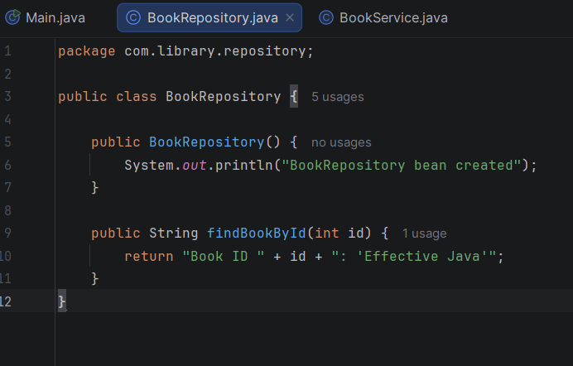
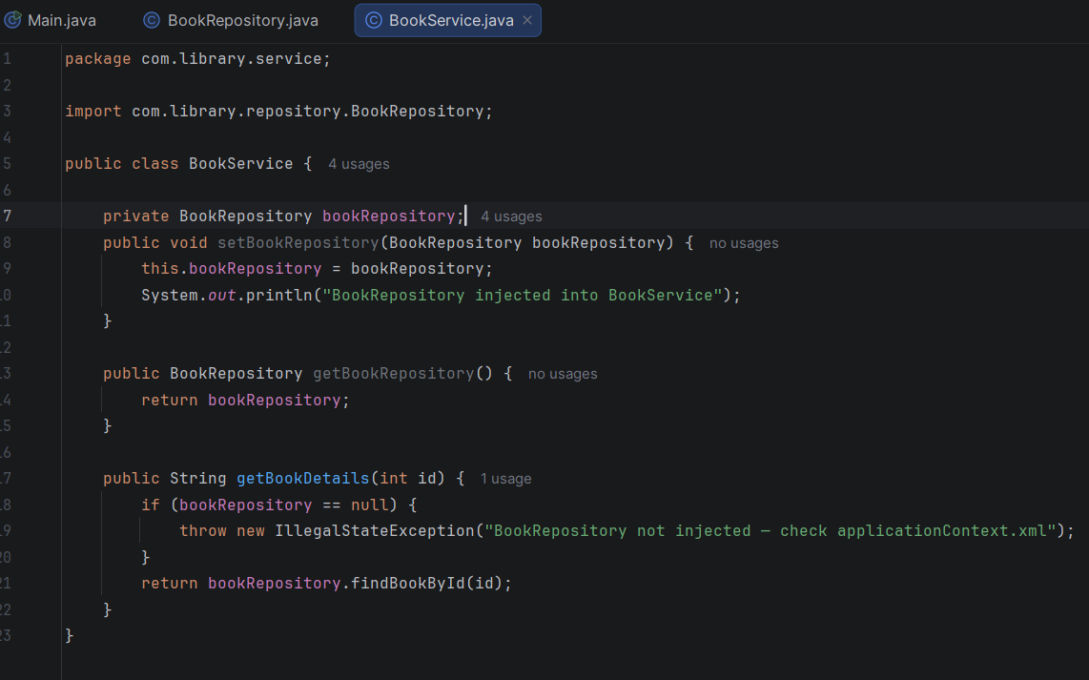
Exercise 7: Implementing Constructor and Setter Injection
Scenario:
The library management application requires both constructor and setter injection for better control over bean initialization.
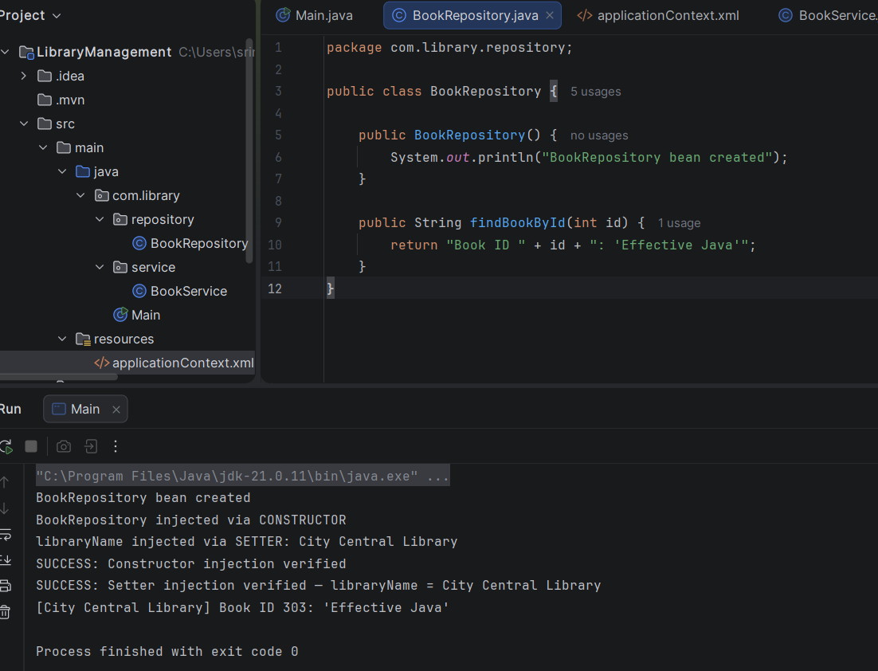
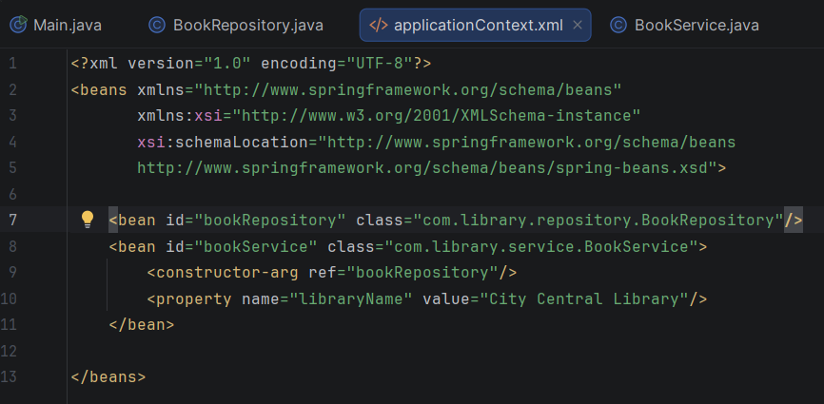
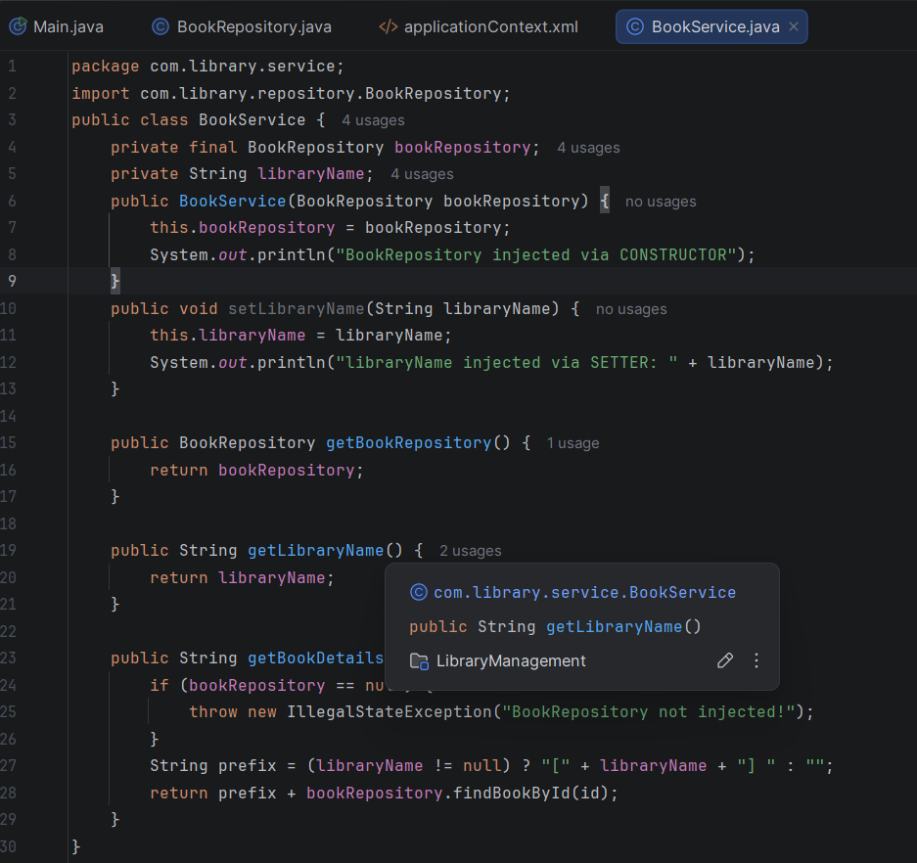
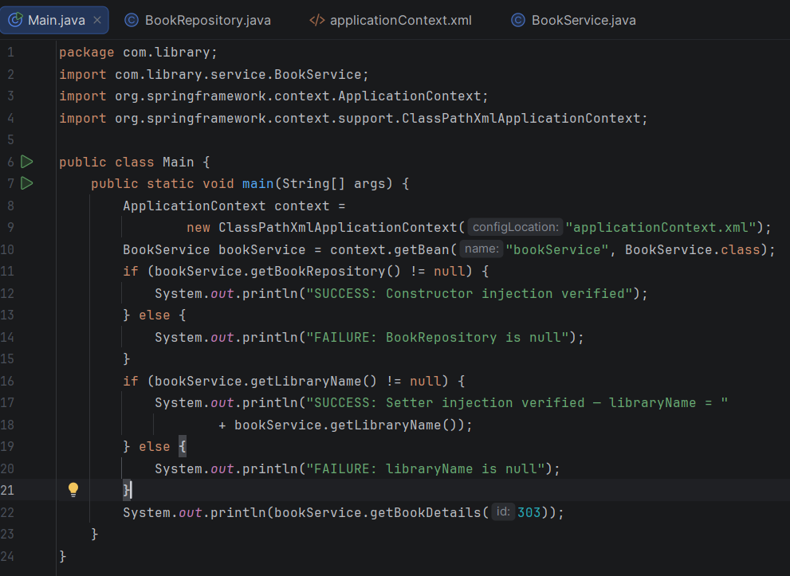
Exercise 9: Creating a Spring Boot Application
Scenario:
You need to create a Spring Boot application for the library management system to simplify configuration and deployment.
Application.properties
spring.application.name=LibraryManagement1
spring.datasource.url=jdbc:h2:mem:librarydb
spring.datasource.driverClassName=org.h2.Driver
spring.datasource.username=sa
spring.datasource.password=
spring.jpa.database-platform=org.hibernate.dialect.H2Dialect
spring.jpa.hibernate.ddl-auto=update
spring.jpa.show-sql=true
spring.h2.console.enabled=true
spring.h2.console.path=/h2-console
server.port=8080

Book Entity
package com.library.entity;
import jakarta.persistence.Entity;
import jakarta.persistence.GeneratedValue;
import jakarta.persistence.GenerationType;
import jakarta.persistence.Id;
@Entity
public class Book {
@Id
@GeneratedValue(strategy = GenerationType.IDENTITY)
private Long id;
private String title;
private String author;
private String isbn;
public Book() {
}
public Book(String title, String author, String isbn) {
this.title = title;
this.author = author;
this.isbn = isbn;
}
public Long getId() {
return id;
}
public void setId(Long id) {
this.id = id;
}
public String getTitle() {
return title;
}
public void setTitle(String title) {
this.title = title;
}
public String getAuthor() {
return author;
}
public void setAuthor(String author) {
this.author = author;
}
public String getIsbn() {
return isbn;
}
public void setIsbn(String isbn) {
this.isbn = isbn;
}
}
Book Repository
package com.library.repository;
import com.library.entity.Book;
import org.springframework.data.jpa.repository.JpaRepository;
import org.springframework.stereotype.Repository;
@Repository
public interface BookRepository extends JpaRepository<Book, Long> {
}
Book controller
package com.library.controller;
import com.library.entity.Book;
import com.library.repository.BookRepository;
import org.springframework.beans.factory.annotation.Autowired;
import org.springframework.http.HttpStatus;
import org.springframework.http.ResponseEntity;
import org.springframework.web.bind.annotation.*;
import java.util.List;
@RestController
@RequestMapping("/api/books")
public class BookController {
@Autowired
private BookRepository bookRepository;
// CREATE
@PostMapping
public Book createBook(@RequestBody Book book) {
return bookRepository.save(book);
}
// READ - all books
@GetMapping
public List<Book> getAllBooks() {
return bookRepository.findAll();
}
// READ - single book by id
@GetMapping("/{id}")
public ResponseEntity<Book> getBookById(@PathVariable Long id) {
return bookRepository.findById(id)
.map(ResponseEntity::ok)
.orElse(ResponseEntity.notFound().build());
}
// UPDATE
@PutMapping("/{id}")
public ResponseEntity<Book> updateBook(@PathVariable Long id, @RequestBody Book bookDetails) {
return bookRepository.findById(id)
.map(book -> {
book.setTitle(bookDetails.getTitle());
book.setAuthor(bookDetails.getAuthor());
book.setIsbn(bookDetails.getIsbn());
return ResponseEntity.ok(bookRepository.save(book));
})
.orElse(ResponseEntity.notFound().build());
}
// DELETE
@DeleteMapping("/{id}")
public ResponseEntity<Void> deleteBook(@PathVariable Long id) {
if (!bookRepository.existsById(id)) {
return ResponseEntity.notFound().build();
}
bookRepository.deleteById(id);
return ResponseEntity.status(HttpStatus.NO_CONTENT).build();
}
}
Library Management application
package com.library;
import org.springframework.boot.SpringApplication;
import org.springframework.boot.autoconfigure.SpringBootApplication;
@SpringBootApplication
public class LibraryManagementApplication {
public static void main(String[] args) {
SpringApplication.run(LibraryManagementApplication.class, args);
}
}
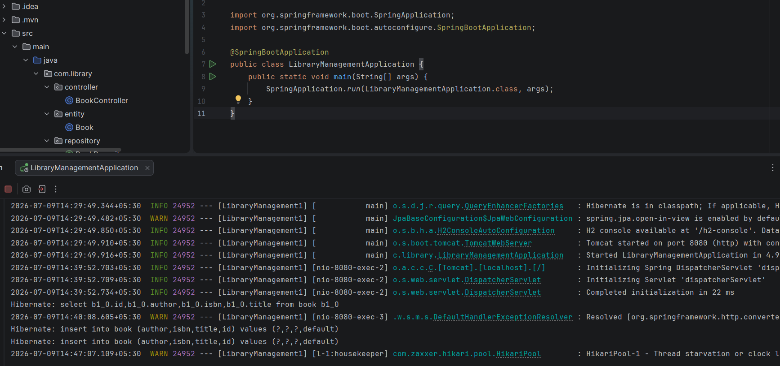
Testing in postman

Posting a new book
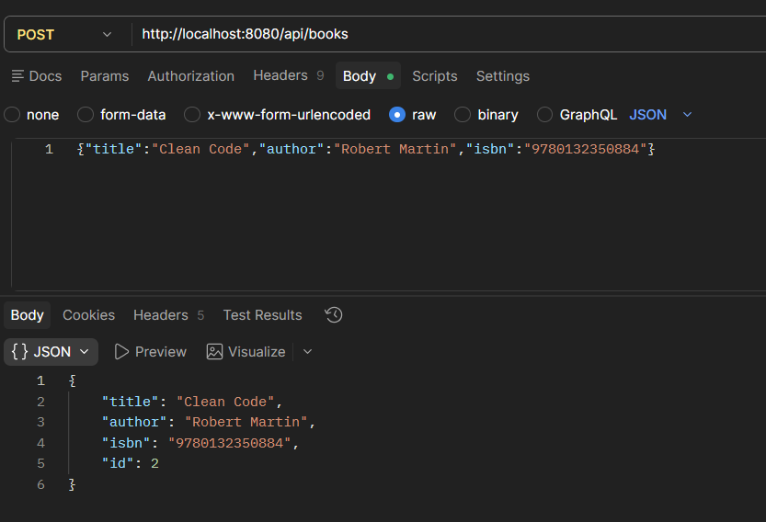

Getting all books
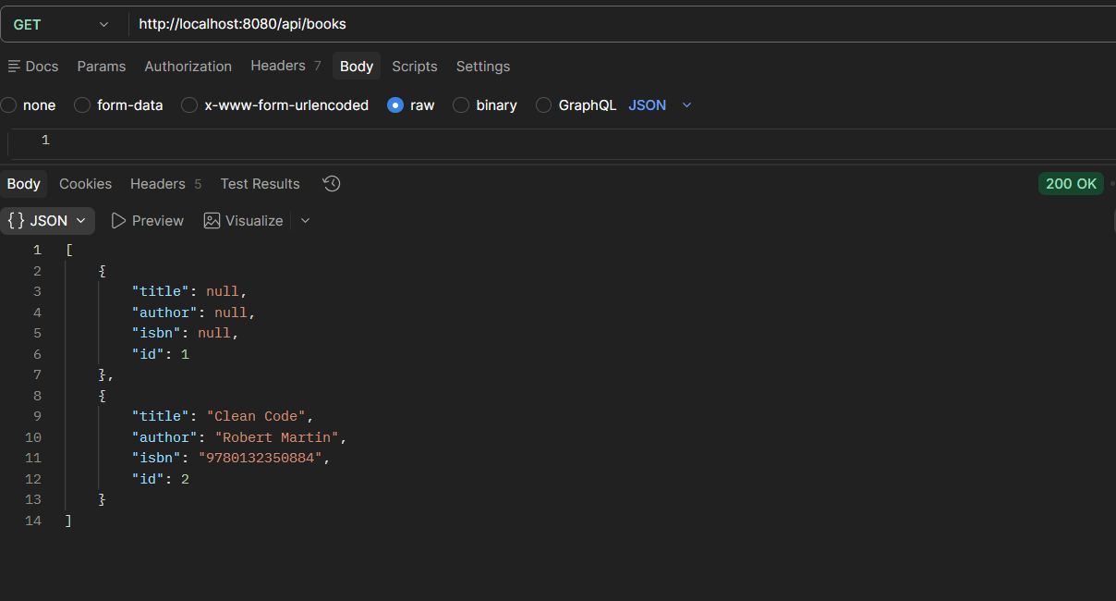

Get a book by its ID
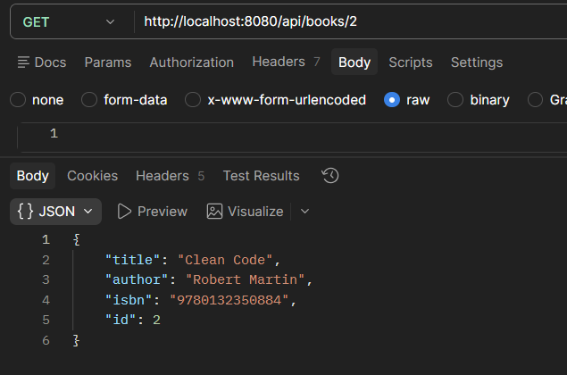

Delete a book by its ID
